📊 IPL Analysis (2008-2024) Dashboard

🎯 Purpose of the Dashboard
This dashboard is created to analyze and visualize IPL (Indian Premier League) data from 2008 to 2024.
It helps in:
- Understanding match performance and outcomes
- Analyzing team and player statistics
- Identifying scoring patterns and trends
- Supporting data-driven insights in sports analytics
📄 Reference report used in this project:

🧱 Step-by-Step Structure to Build the Dashboard

📌 PART 1: Primary KPI Section
🔹 What we are making:
Key performance indicators (KPIs) to give a quick summary of match and team data.
🔧 KPIs to Create:
- Total Matches
- Total Runs
- Total Wins
- Win Percentage
- Total Wickets
- Highest Team Score
📊 Visualizations:
- Card visuals (big bold numbers)
- KPI tiles
- Icons for better visualization
📌 Example (Page 6):
- Matches: 16
- Runs: 2568
- Win %: 56.25

🏏 PART 2: Match Analysis Section
🔹 What we are making:
Detailed match-level analysis.
📊 Includes:
- Teams and scores
- Toss winner & decision
- Venue
- Match type
- Winner
📌 Example (Page 1):
- MI vs KXIP → 176/176 tie
- Double Super Over → KXIP won
📊 Visualizations:
- Cards
- Text visuals
- Dynamic filters
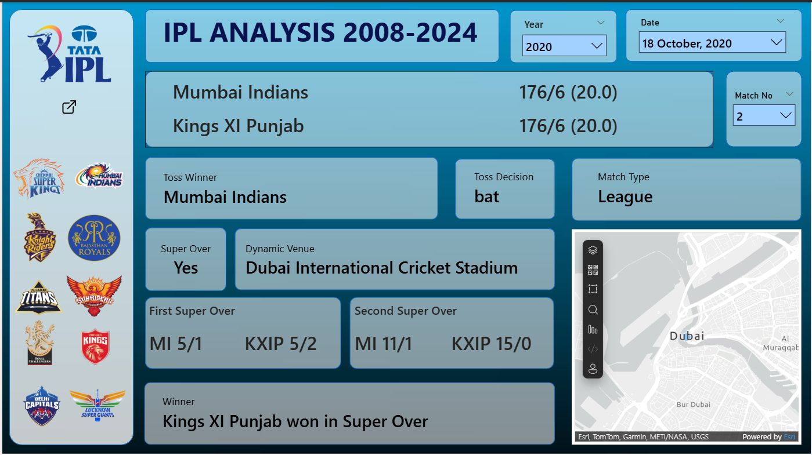

📈 PART 3: Running Total Analysis
🔹 What we are making:
Cumulative runs scored over each over.
📊 Visualizations:
- Line Chart
- X-axis: Overs (0–20)
- Y-axis: Total Runs
📌 Insight (Page 2–3):
- Both teams showed similar run progression
- Close competition throughout the match
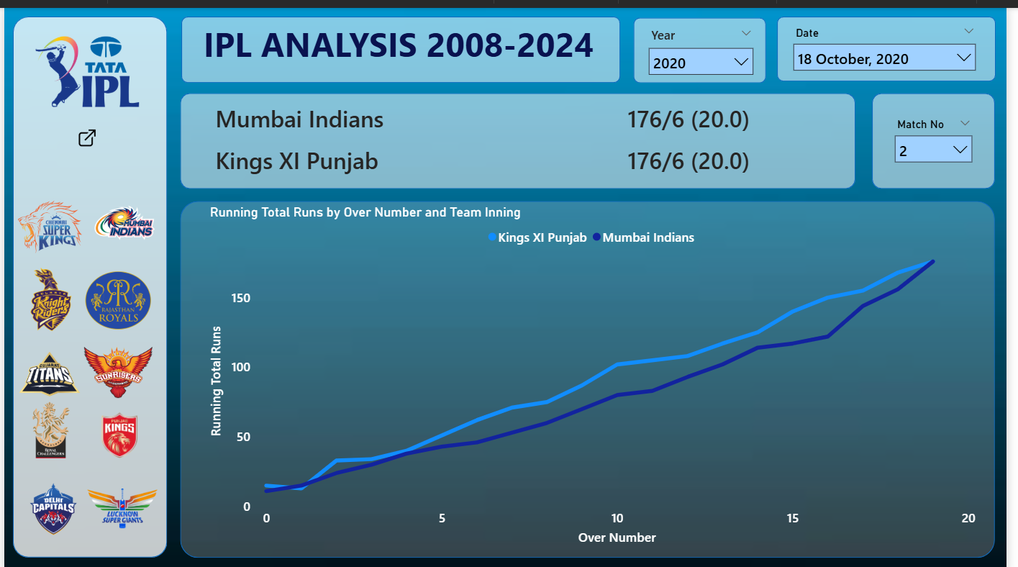

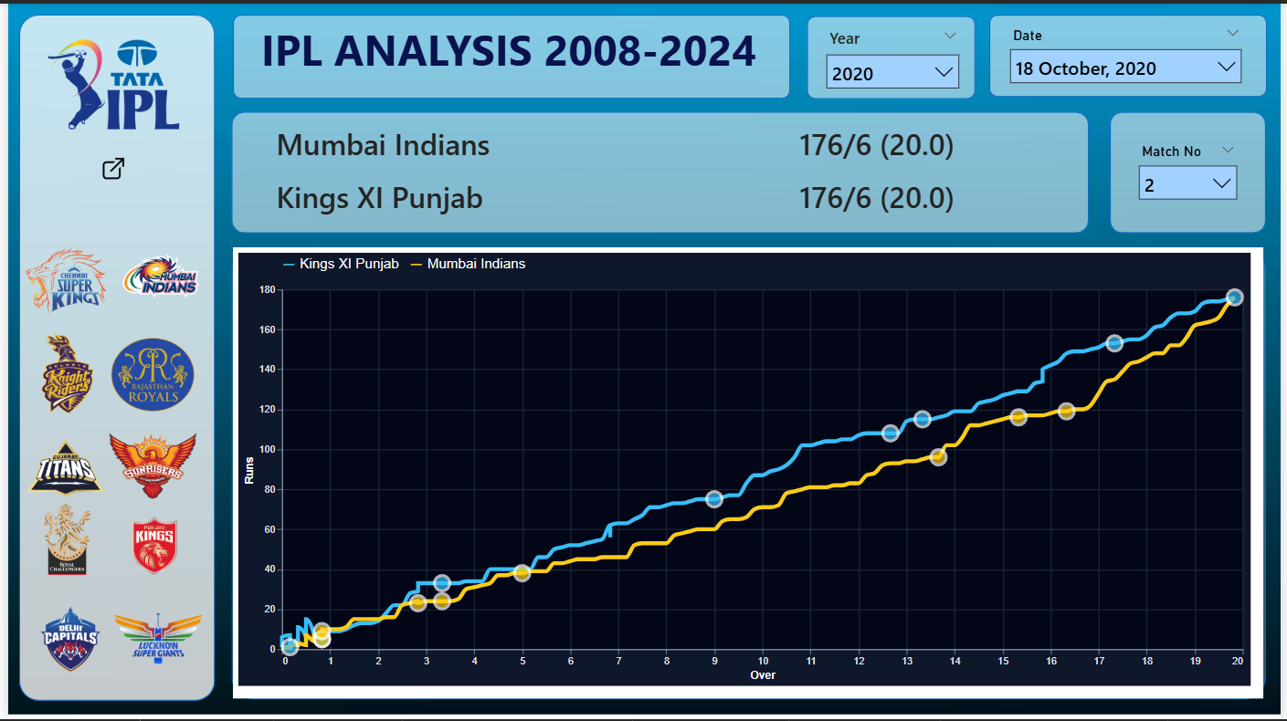
⚡ PART 4: Runs Per Over Analysis
🔹 What we are making:
Analyze scoring pattern per over.
📊 Visualizations:
- Clustered Bar Chart
- Compare both teams over each over
📌 Insight (Page 4):
- High scoring overs indicate power hitting
- Low scoring overs show bowling dominance
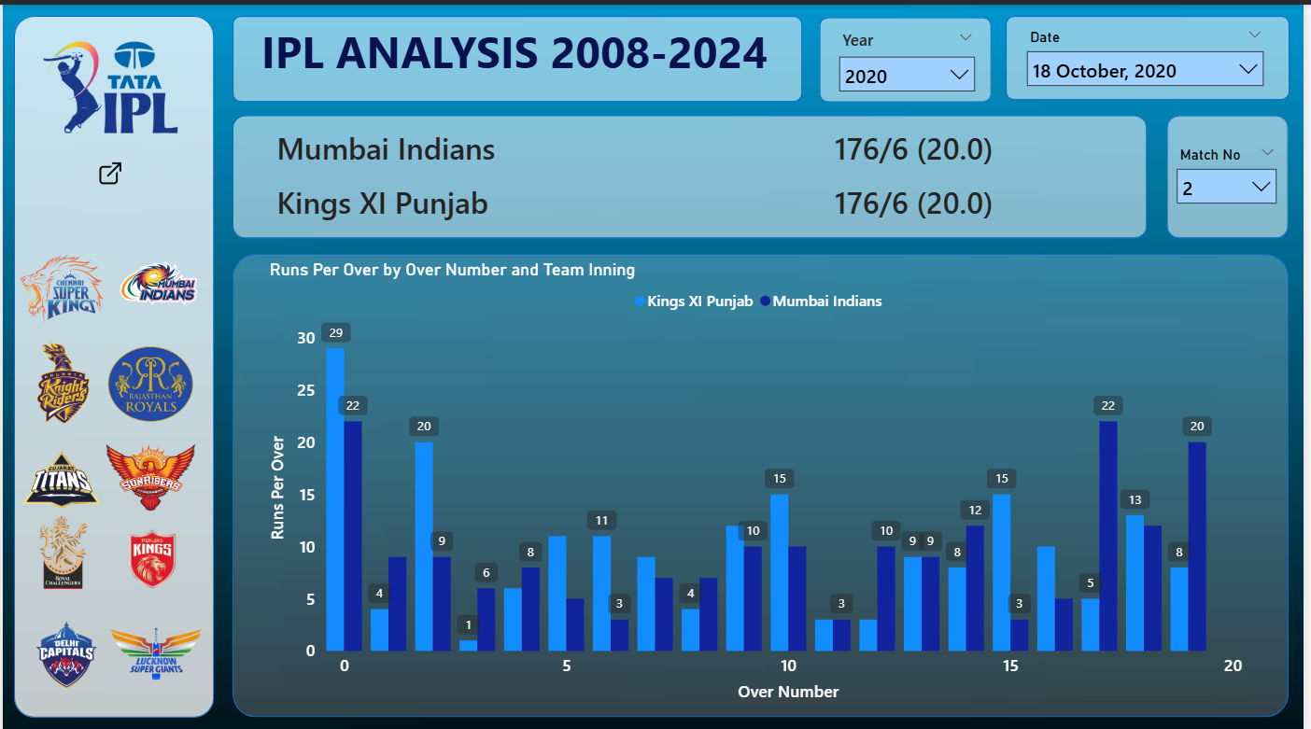

🏆 PART 5: IPL Winners Analysis
🔹 What we are making:
Team-wise title comparison.
📊 Visualizations:
- Horizontal Bar Chart
📊 Data:
- Mumbai Indians → 5 Titles
- Chennai Super Kings → 5 Titles
- KKR → 3 Titles
📌 Insight (Page 5):
- MI and CSK dominate IPL history
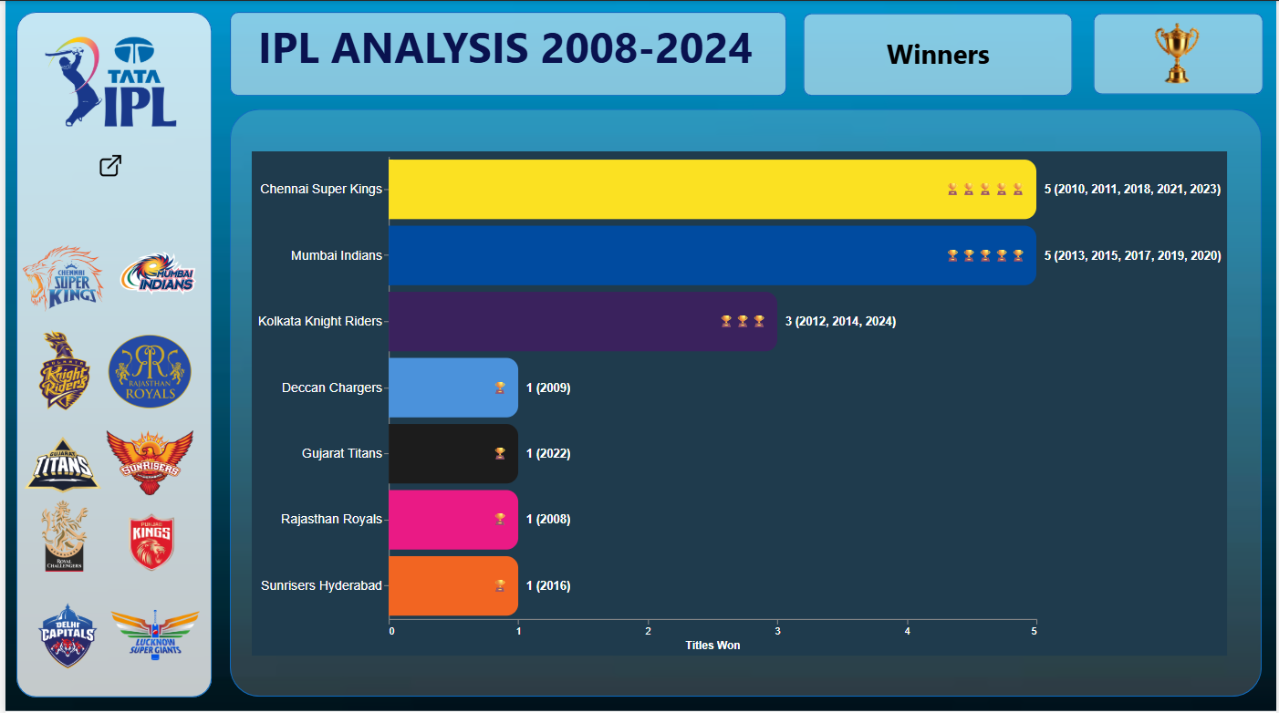

📊 PART 6: Team Performance Dashboard
🔹 What we are making:
Detailed team statistics.
📊 Includes:
- Matches played
- Wins & losses
- Batting average
- Bowling average
- Boundaries
📌 Example (Page 6):
- CSK (2008):
  - Wins: 9
  - Avg: 25.89
  - Wickets: 83
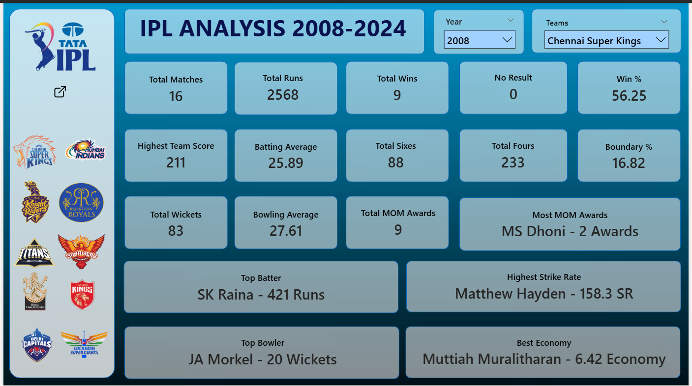

📋 PART 7: Points Table Analysis
🔹 What we are making:
Season-wise team standings.
📊 Visualizations:
- Table with conditional formatting
📊 Includes:
- Matches
- Wins/Losses
- Points
- Net Run Rate
📌 Example (Page 7):
- Winner: Kolkata Knight Riders
- Top Points: 20
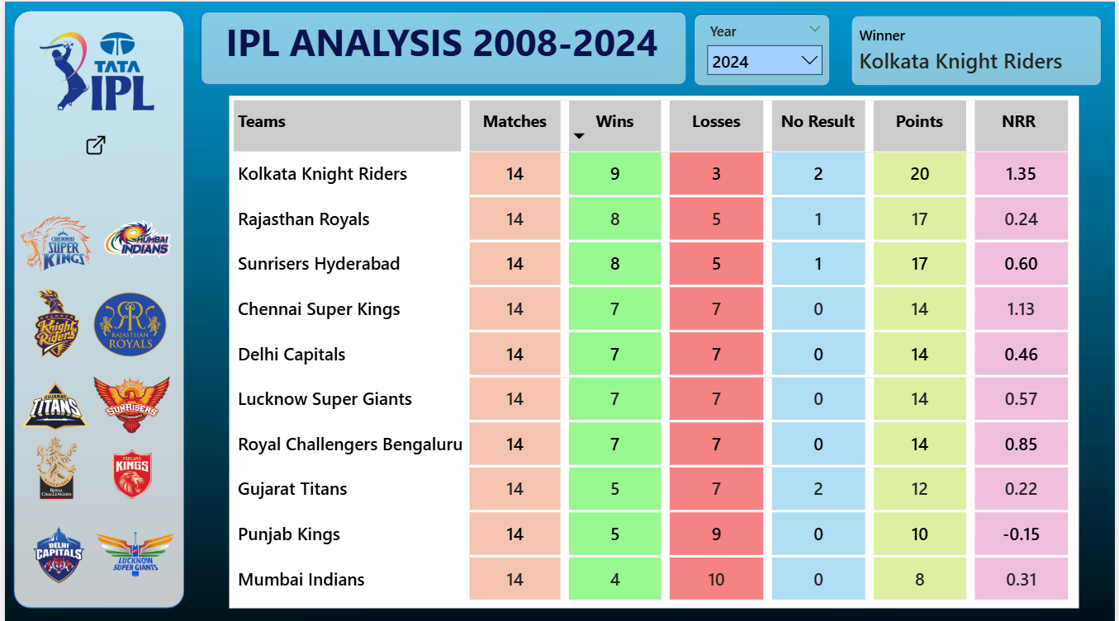

👤 PART 8: Player Performance Analysis
🔹 What we are making:
Individual player statistics dashboard.
📊 Includes:
- Runs
- Strike Rate
- Average
- Matches
- 4s & 6s
📌 Example (Page 8):
- Virat Kohli:
  - Runs: 165
  - SR: 105.09
  - Avg: 15
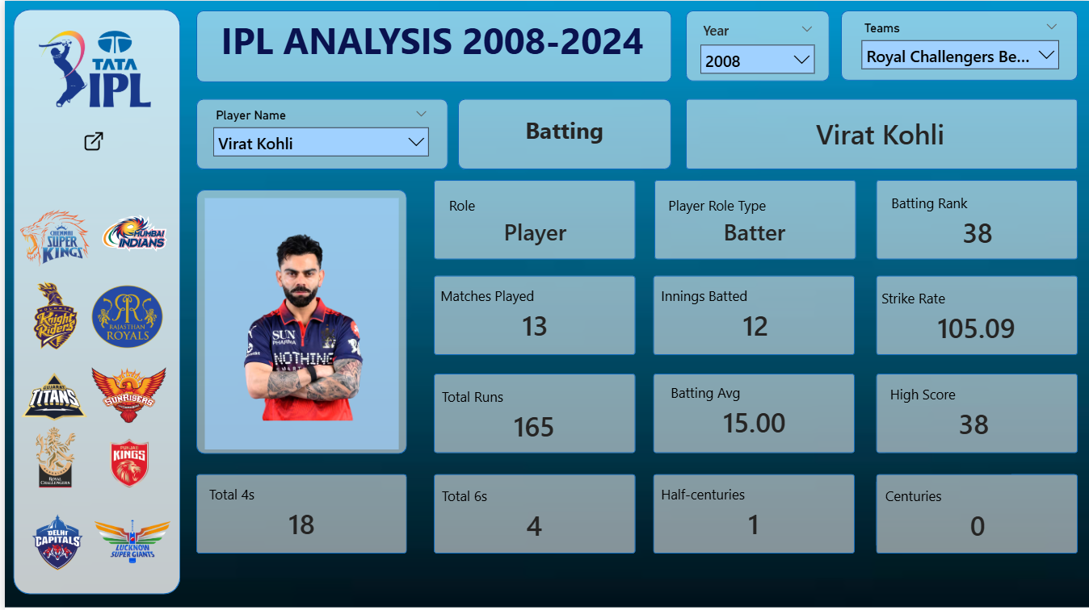

🎛️ PART 9: Filter Panel
🔹 What we are making:
Interactive filtering system.
📊 Filters:
- Year
- Date
- Match Number
- Team
- Player
📊 Visualizations:
- Slicers
- Dropdown filters

🗂️ Data Setup Recommendation
- Use clean dataset with:
  - Match data
  - Player data
  - Team data
- Use Power BI relationships
- Create calculated columns:
  - Year
  - Over number
  - Strike rate

🛠️ Tools & Features Used
Feature | Use Case
Power BI | Dashboard creation
Power Query | Data cleaning
DAX | Calculations
Cards | KPI display
Line Chart | Run trends
Bar Chart | Over analysis
Table | Points table
Slicers | Filtering

🔍 Key Insights
- IPL matches can be highly competitive (tie + super over cases)
- MI and CSK are most dominant teams
- Middle overs play crucial role
- Player performance impacts match outcome

🚀 Conclusion
This IPL dashboard demonstrates how data analytics and visualization can be applied in sports.
It provides:
- Interactive insights
- Performance comparison
- Historical trends
👉 Useful for:
- Data Analysts
- Cricket Analysts
- Sports Enthusiasts

